Manual on how to connect the device to Cloud

1. If you haven't already, create a project in Google Cloud. To create a project, click here:

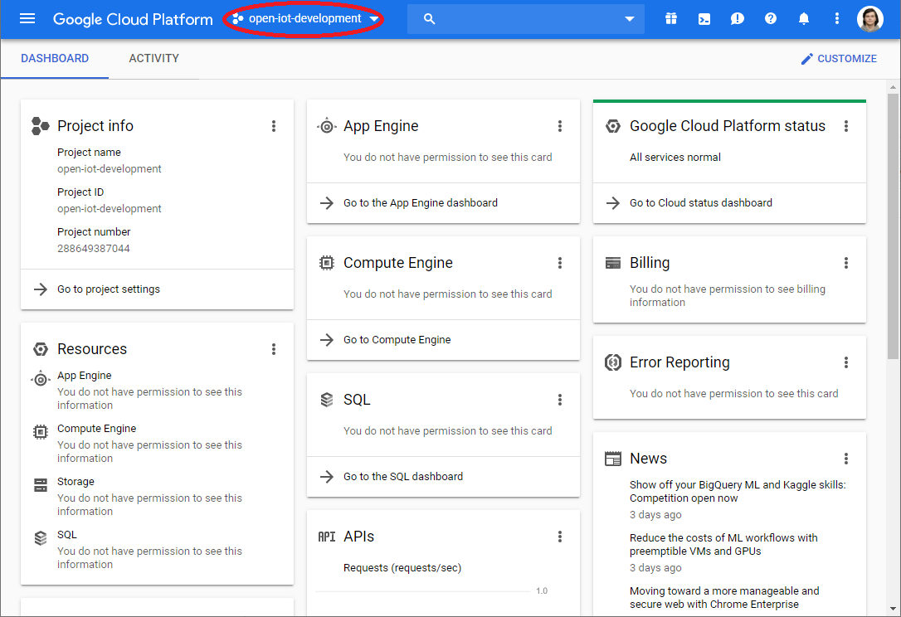

After, click on NEW PROJECT button and enter your Project name and location:

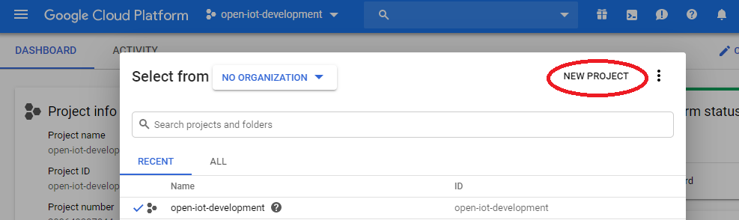

1. After you have a project, go to the navigation menu in the top left corner and find IoT Core or just type IoT in the search bar.

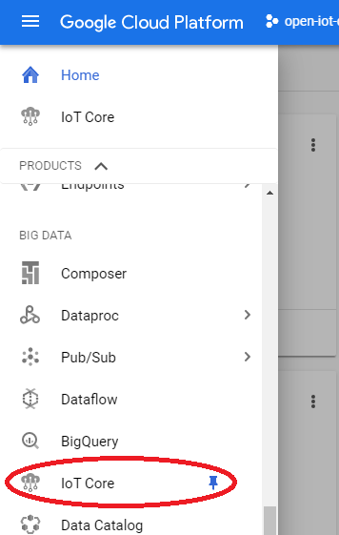

Now you should see the Registries page. Here, click on a “create registry” button.

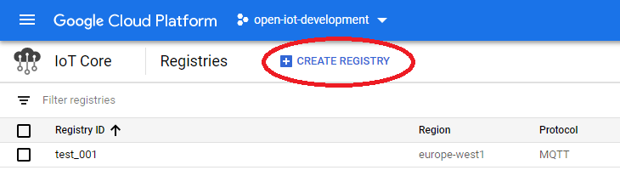

For topic fields, you have to create a topic. You can use one topic for telemetry and state fields, or create topics for each of them. Here is an example of filled out registry:

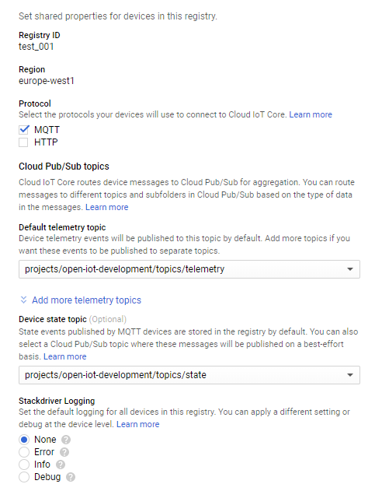

You must fill out all required fields and hit the Create button.

1. For a device to function properly you need to enter keys that are generated on the device. Read the instructions [here](https://github.com/DAVFoundation/mooving-iot-firmware) on how to generate keys on the device.

In the process of setting up your device, you will do these steps:

8. Generate ES256 encryption keys:  
 sudo sh generate_keys.sh

9. Add device public key on Google Cloud IoT. To display the generated device public key, enter:  
 sudo cat ../keys/ec_public.pem

After doing them, you should see in your console generated security key:

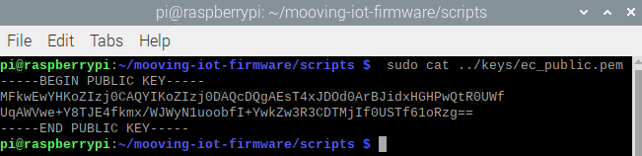

Copy them and go to the Devices tab on left and create a new device.

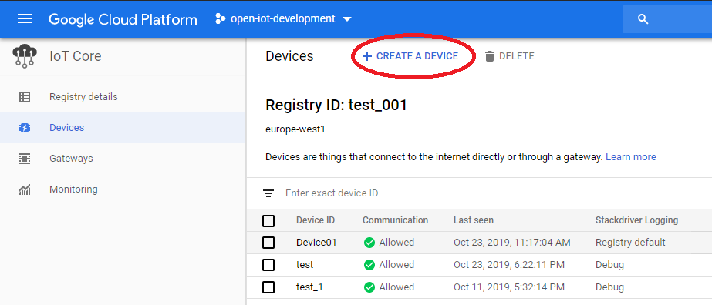

In the opened window enter device ID, in the “Public key format” select ES256 and in the “Public key value” field enter the generated key.  
The final result should look like this:

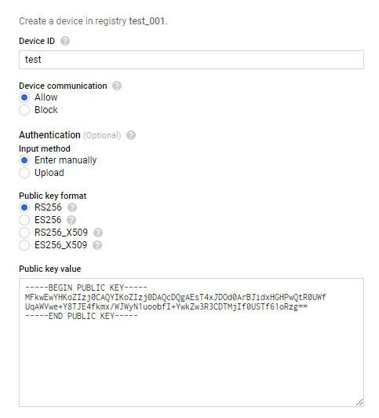

After you finished filling out all required fields, click on the “Create” button and you will be transferred to your created device page.

1. Before sending any commands to the device you need to send the configuration to it. For this, click on “UPDATE CONFIG” button:

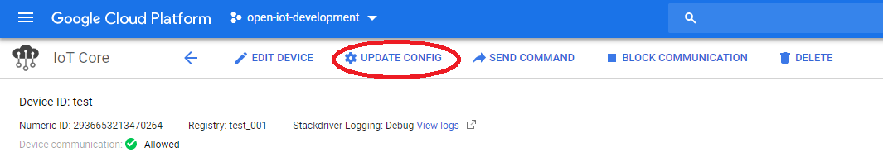

In the appeared “Update configuration” window message enter this JSON:

{

"telemetryIntervalPowerOn": 10,

"telemetryIntervalPowerOff": 10

}

And click on “Send to device” button.

To send commands you need to click on the “SEND COMMAND” button.

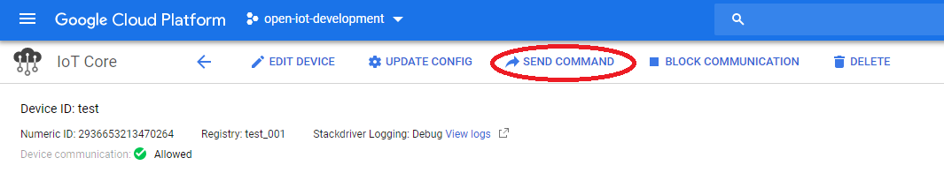

And in the appeared “Update configuration” window message enter the command from the list below and click on “Send command” button:

*In "vehicleId" field you should enter the name of your device ID, so if your Device ID is “test”, the commands are:*

To unlock:

{

"command": "unlock",

"vehicleId":"test"

}

To lock:

{

"command": "lock",

"vehicleId":"test"

}

To set to unavailable:

{

"command": "unavailable",

"vehicleId":"test"

}

To make a constant beep pattern (volume is from 1 to 100):

{

"command": "beep",

"volume": 50,

"vehicleId":"test"

}

To make a constant alarm pattern (volume is from 1 to 100):

{

"command": "alarm",

"volume": 50,

"vehicleId":"test"

}